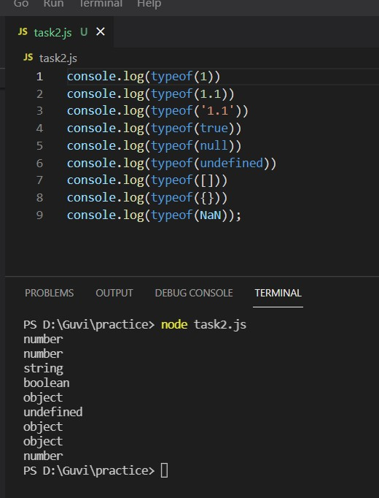

Execute the below code and write your description in a text file

* 1. typeof(1)

-Returns Number type as we have mentioned 1

* 1. typeof(1.1)

-Returns type as Number even if it’s decimal as JS don’t have a decimal data type and all decimals are considered as the numbers in JS.

* 1. typeof('1.1')

-Returns type as String as the numbers are quoted and String data type always be covered with Quotes

* 1. typeof(true)

-Returns the Boolean data type

* 1. typeof(null)

-In JavaScript, typeof null is 'object', which incorrectly suggests that null is an object as Null itself is a primitive data type

* 1. typeof(undefined)

-Type of Undefined is undefined

* 1. typeof([])

-Returns the Object data type

* 1. typeof({})

-Curly braces indicate the key-value pair object and return object data type

* 1. typeof(NaN)

-Returns the number data type as NaN is considered to be a number